

National University of Computer and Emerging Sciences



Assignment # 3

**Student:**

Abdul Rehman ………… 19L-1135

**Section:**

Artificial Intelligence(BCS-7B)

**Instructor:**

**Mubasher Baig**

**Q1:**

**Q2:**

**Q3:**

**1.**

1. (2^100)-1

2. 100

3.

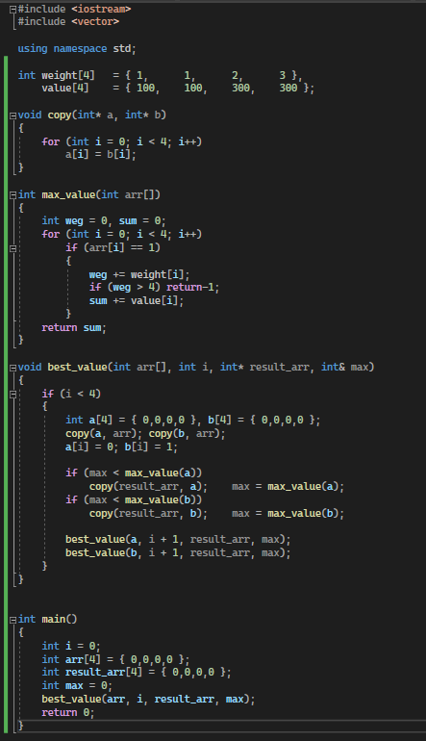

|  |  |  |  |  |  |  |  |  |
| --- | --- | --- | --- | --- | --- | --- | --- | --- |
| **2.** |  |  |  |  |  |  |  |  |
|  | A | B | C | D | Weight | Value | If W <= MC |  |
|  | 0 | 0 | 0 | 0 | 0 | 0 | 0 |  |
|  | 0 | 0 | 0 | 1 | 3 | 300 | 300 |  |
|  | 0 | 0 | 1 | 0 | 2 | 300 | 300 |  |
|  | 0 | 0 | 1 | 1 | 5 | 600 | - |  |
|  | 0 | 1 | 0 | 0 | 1 | 100 | 100 |  |
|  | 0 | 1 | 0 | 1 | 4 | 400 | 400 |  |
|  | 0 | 1 | 1 | 0 | 3 | 400 | 400 |  |
|  | 0 | 1 | 1 | 1 | 6 | 700 | - |  |
|  | 1 | 0 | 0 | 0 | 1 | 100 | 100 |  |
|  | 1 | 0 | 0 | 1 | 4 | 400 | 400 |  |
|  | 1 | 0 | 1 | 0 | 3 | 400 | 400 |  |
|  | 1 | 0 | 1 | 1 | 6 | 700 | - |  |
|  | 1 | 1 | 0 | 0 | 2 | 200 | 200 |  |
|  | 1 | 1 | 0 | 1 | 5 | 500 | - |  |
|  | 1 | 1 | 1 | 0 | 4 | 500 | 500 |  |
|  | 1 | 1 | 1 | 1 | 7 | 800 | - |  |
|  |  |  |  |  |  |  |  |  |

**Q4:**

**Q5:**

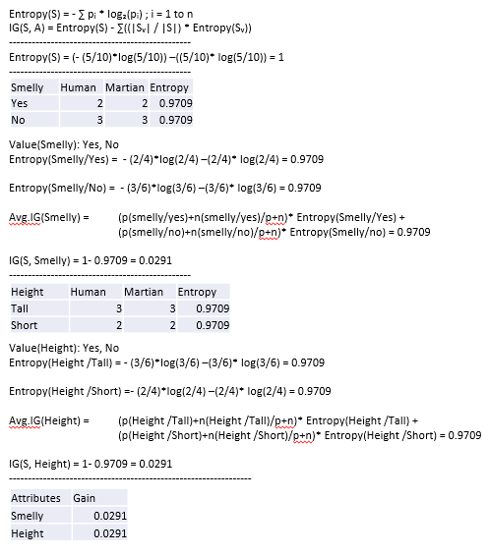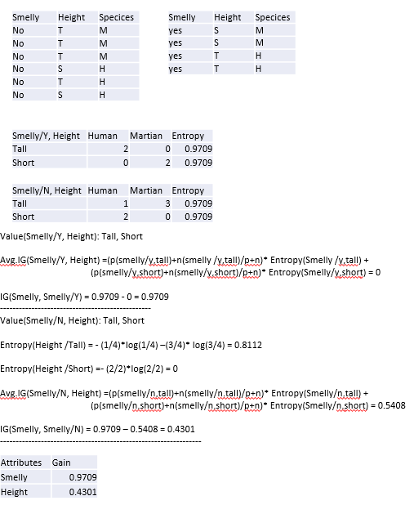

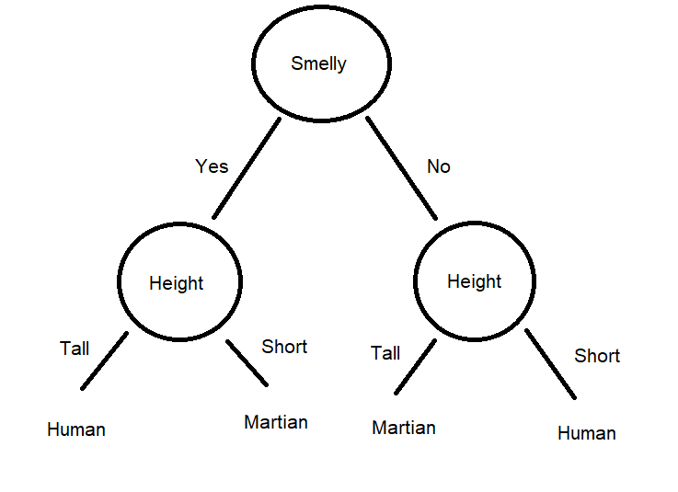

**Q6:**

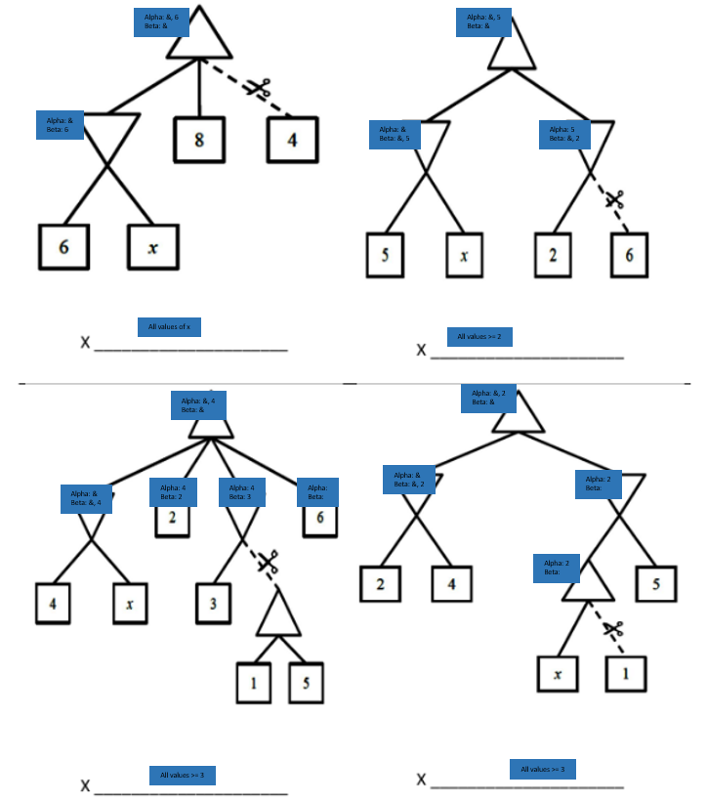

**Q7:**

1. **7 states**

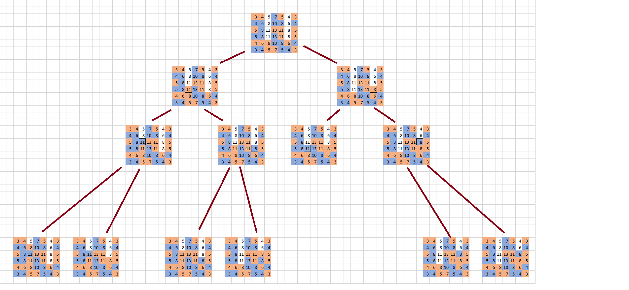

Initially, we have red(player) as 104 and blue(ai) as 110, resulting -7.  
so by adding and subtracting, we can get end values and generate a minimax tree.

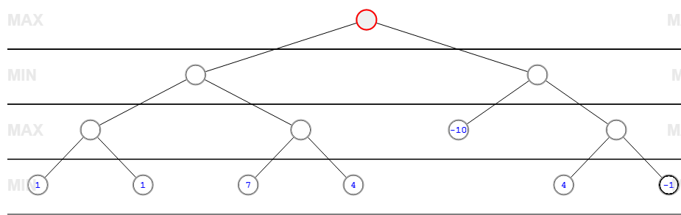

With pruning, we get

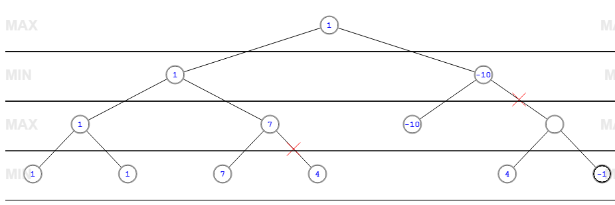

**3.**

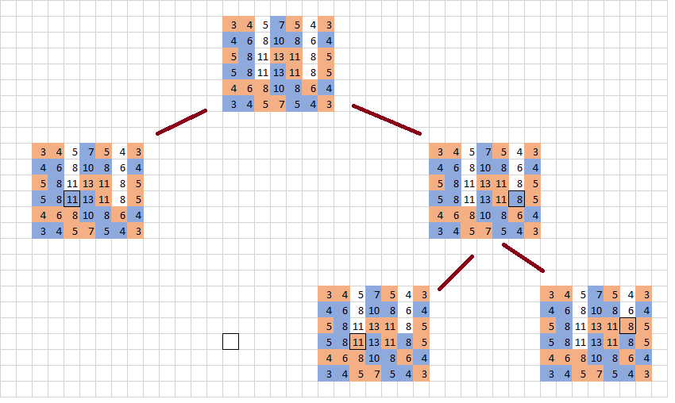

Initially, we have red(player) as 104 and blue(ai) as 110, resulting 7.  
so by adding and subtracting, we can get end values and generate a minimax tree

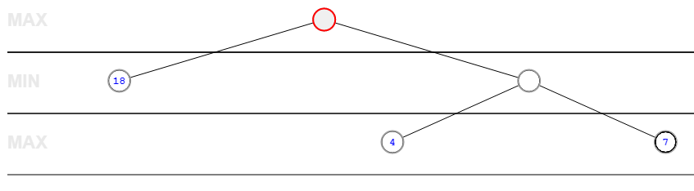

With pruning, we get

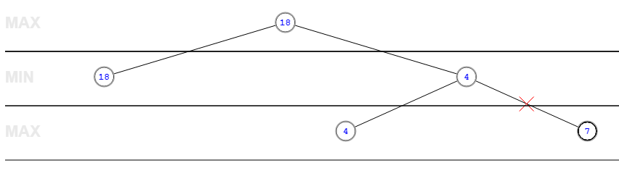

**Q8:**

**1.**

|  |  |  |  |
| --- | --- | --- | --- |
|  | Distance From C1 | Distance From C2 | Distance From C3 |
| A1 | 0 | 5 | 9 |
| A2 | 5 | 6 | 4 |
| A3 | 12 | 7 | 9 |
| A4 | 5 | 0 | 10 |
| A5 | 10 | 5 | 9 |
| A6 | 10 | 5 | 7 |
| A7 | 9 | 10 | 0 |
| A8 | 3 | 2 | 10 |

**2.**

|  |  |  |
| --- | --- | --- |
| C1 | C2 | C3 |
| A1 | A3 | A2 |
|  | A4 | A7 |
|  | A5 |  |
|  | A6 |  |
|  | A8 |  |

**3.**

New C1 = (2,10)

New C2 = (6,6)

New C3 = (1.5,3.5)

**4.** 